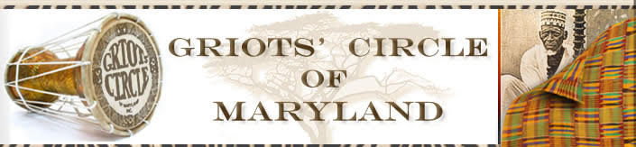

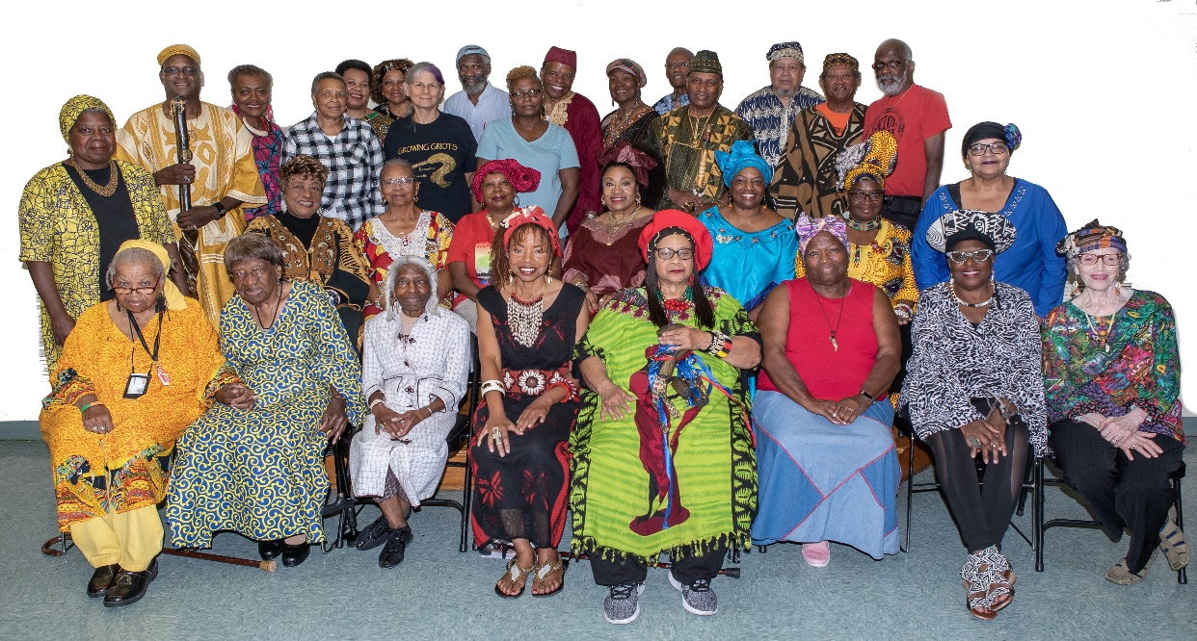
The Griots' Circle of Maryland has declared that 2019 is the "Year of Mother Mary Carter Smith". All programs and performances done by the Griots' as a organization or as an individuals, Mother Mary will be acknowledged. We started this year celebrating the 100th anniversary of Mother Mary's birth on her actual birthday, February 10, 2020 with over a hundred people were in attendance commemorating her life and legacy.
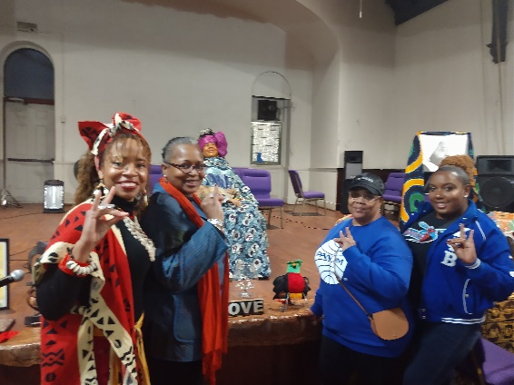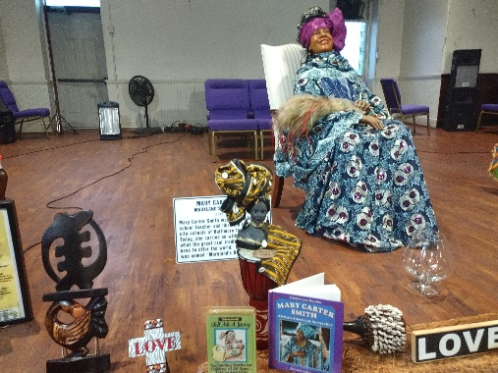
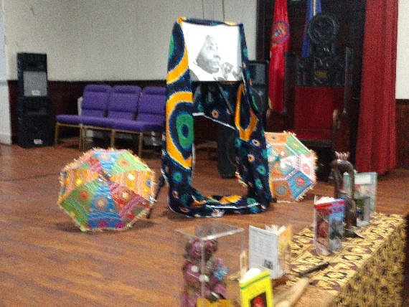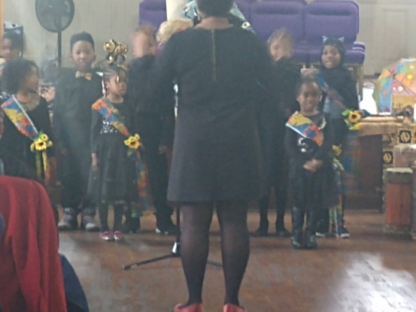
April 13, 2019, "Bring the Pain and Heal: Uplifting Our Youth". Community leaders from various organizations performed or just came to meet and greet. This event included, storytelling, comedian, African drumming, boy scouts, give aways, food. It was open to the public. $5 admission proceeds went to the first human "Red, Black and Green" flag committee for their upcoming event on August 17, 2019
May 4, 2019, annual "Spring Fling." New members get a chance to show off their skills to the Griots' Circle and public.
The Growing Griots completed their 10th successful year in May 2019. The Growing Griots told stories and one of the growing griots even debuted a short film that he entered in contest.
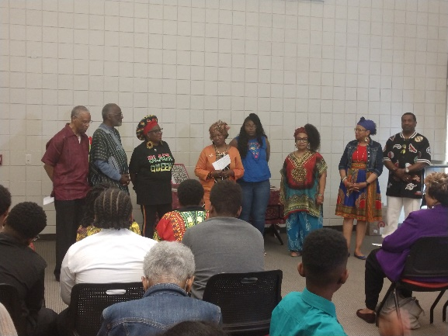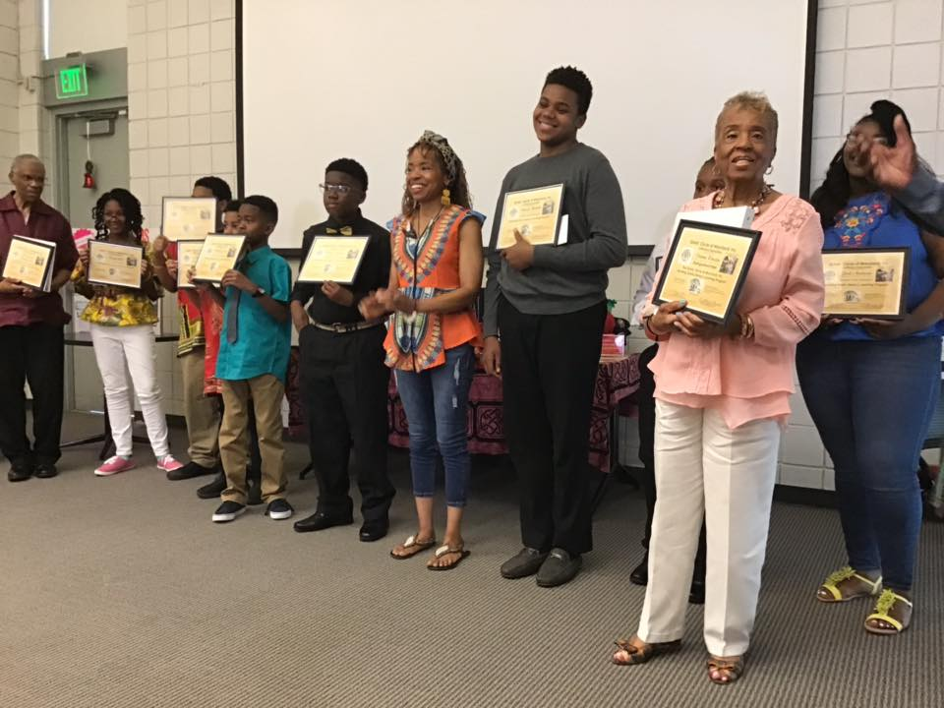
The Growing Griots performed at the National Great Blacks in Wax Museum in February.
In April the Growing Griots conducted the Sankofa Inter- generational Oral History Project Interviews.
The Griots' Circle & Growing Griots took part in the Griots Book Fair & Juneteenth Celebration.
In JULY the Griots Circle & Growing Griots partnered with the National Great Blacks in Wax Museum celebrating the 5th Annual Voices of History Street Fair.
In August the Griots Circle took part in creating the human African Liberation Flag.
In September (21) the Griots Circle performed at the Maryland Commission on African American History & Culture's Harambe Storytelling Program at the Bannaker Douglass Museum in Maryland's Capitol of Annapolis.
August 18, 2019; recipient of a "mash up grant" from the Peale Center. A crankie artist was paired with the Griots."Sankofa: Moving Forward and Backward Through Moments in Time" was the title of the program opened to the public. Mama Linda, Anokwale, David Fakunle, and guests, Delencia Greene and Maura Dwyer performed.
September 2019
Griots performed in the Douglass Banneker Museum
"Giving and Receiving Love from GRANDmother Earth" with special guests, indigenous flute player, Louis Eagle Warrior and indigenous dancer Malachi. Griots held an event at the American Visionary Arts Museum open to the public.
.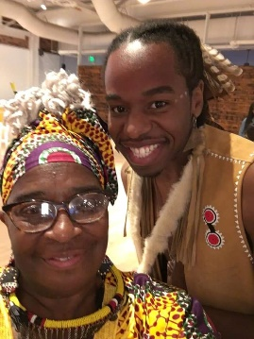 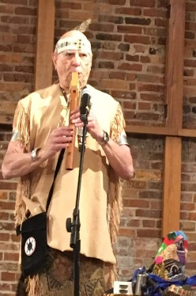 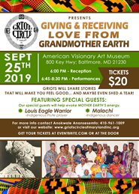 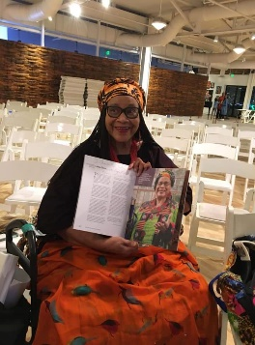 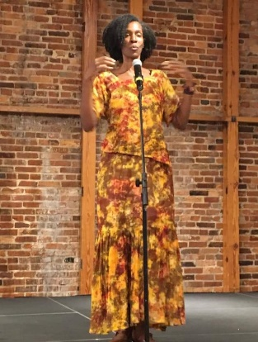 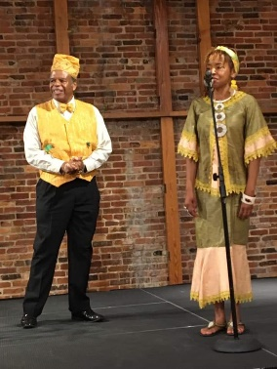 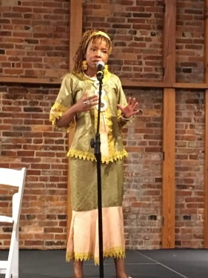 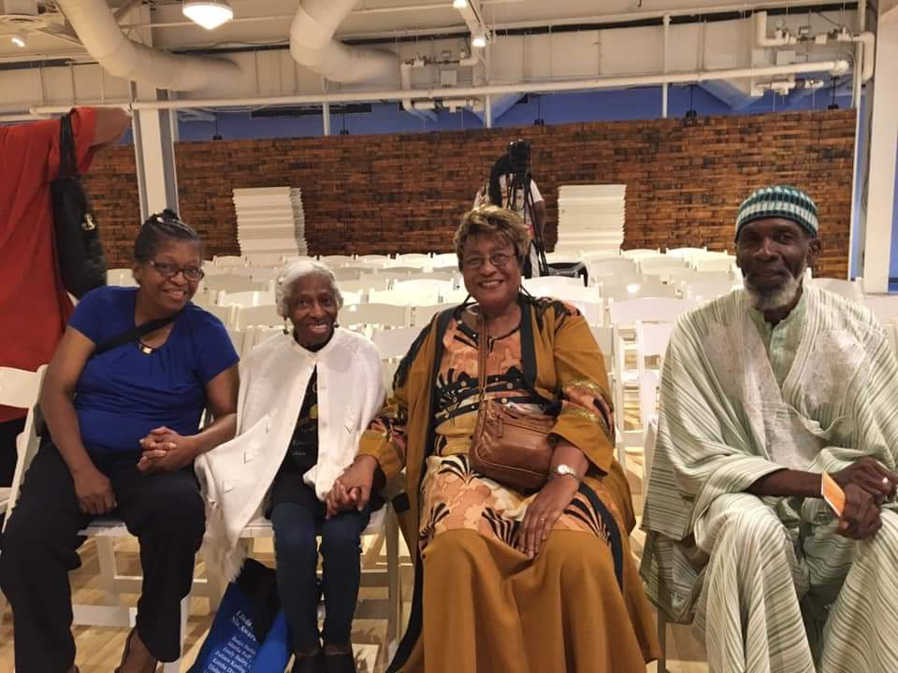
October 20, 2019 annual fundraising event Love stories. "Love Is..." Members tell stories with the theme of love.
Website was updated and totally redone. We can accept payments on line now and list members profiles and upcoming events. Social media, Facebook is regularly updated. "Likes" have more than doubled and has generated new members.
In December the Griots' Circle & Growing Griots will hold its annual Kwanzaa event which is the largest Kwanzaa Celebration in Baltimore.
The Griots will perform at the annual “Holidays at Hampton”. We will tell stories in the African Oral tradition with holiday themes.

